**11 Jan 2019** **The Weekly Bulletin of Rotary Club of Kathmandu Mid-Town** **bc-16.1/019**

|  |
| --- |
| C:\Users\Public\Documents\RIP T1819_EN.png |

District: 3292 Web:www.rotarymidtown.org.np Club Id: 26776

**JANUARY IS VOCATIONAL SERVICE MONTH**

**Vocational Service focuses on**:

Adherence to and promotion of the highest ethical standards in all occupations, including fair treatment of employers, employees, associates, competitors, and the public.

The recognition of the worthiness of all useful occupations, not just those that are pursued by Rotarians.

The contribution of your vocational talents to solving the problems of society and meeting the needs of the community.

**Weekly Meeting # 1471: Friday 4 Jan 2019**

In-house speaker Dr Buddha Basnet talked about typhoid, typhus and TB diseases. Typhoid and typhus are different, and sometime there is confusion, and treatment becomes ineffective.

Typhoid is a foodborne illness that infects an estimated 21 million people each year. Transmission is often through contaminated food or water, and symptoms develop within three weeks. Symptoms are usually mild but can be serious. More than 200,000 people die from typhoid every year.

Typhus is a flea-borne disease that affects thousands of people every year. It is often found in the colder mountainous regions of Africa, South America and Asia. Like typhoid, it most commonly occurs in areas where overcrowding and poor hygiene are common.

Despite having fairly similar names, typhoid and typhus have little in common. One major similarity, and why many have thought them to be the same disease for so long, is the symptoms.

Tuberculosis (TB) is a disease caused by bacteria that are spread through the air from person to person. If not treated properly, TB disease can be fatal. People infected with TB bacteria who are not sick may still need treatment to prevent TB disease from developing in the future.

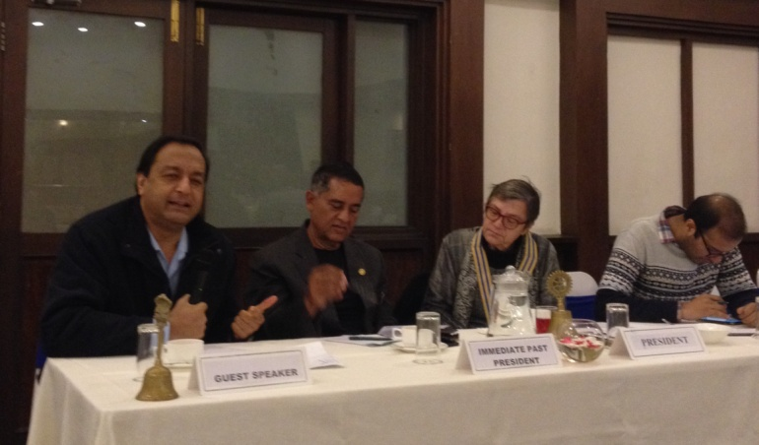 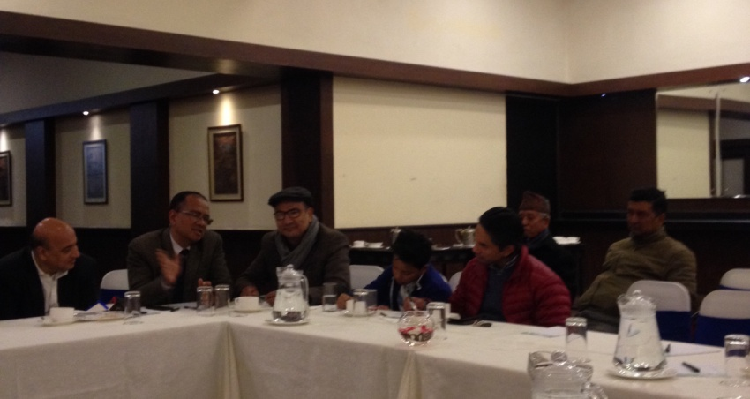

**Weekly Meeting # 1472: Friday 11 Jan 2019**

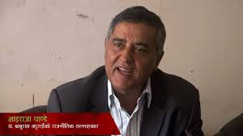

Our own Mid-Towner IPP Bhairaja Panday will be the speaker. He will be talking on

‘Different aspects of Nepal-India relations.’

Rtn Bhairaja Panday lectures on international law at the ICMS. He received his LL.M. from

Yale University, USA in 1983. He holds both an LL.B. and Master's degree in Comparative

Law from Delhi University, as well as a B.Sc. from Tribhuvan University, Kathmandu. He has

served as a UNHCR (United Nations High Commissioner for Refugees) representative for

28 years, leading humanitarian missions in Thailand, Pakistan, Iran, South Sudan, Somalia, Egypt, Angola, Afghanistan, and Myanmar. He held various positions with the UNHCR ranging from posts as a Protection Officer in Somalia and Pakistan to Chief of Mission in Damascus and Operations Manager in South Sudan. He retired as a UNHCR Representative for Myanmar.

**RID 3292 District Conference 2019:**



**11th District Conference is going to be held in Butwal, Gandaki Province**

**22 - 24 February 2019.**

Registration fee (Rs) Upto 31 Dec 2018 Jan 1-Feb 15 2019 Spot Registration

Rotarian/Guest 6,000 6,500 7,000

Rotarian with non-Rotarian

spouse 11,000 12,000 13,000

Rotaract/Interact/RCC 3,000 3,500

100% Registration by any club Rs 5,500 per person (Deadline: 31 Jan 2019)

Early-bird Registration (11th District Conference at Butwal) Rs 5,500 (Rotarian)

and Rs 11,000 (couple)

For more information, contact:

Rom Sharma (Conference Office Secretary); districtconference019@gmail.com

Tanka P. Pokharel (Registration Sub-Committee Chair): Pokhareltp@gmail.com; mobile: 9857021325

**Do you Know ?**

**Animal Poop Is Turning into Deadly Ammonia Pollution !**

It would seem that humans have underestimated the amount of poop their livestock are creating. Scientists know this because they can see it from space.

To be fair, it's not the actual animal poop they can see, but the ammonia being released by said poop. Ammonia (NH3) is a colorless waste gas that forms when nitrogen and hydrogen combine. It occurs in small amounts everywhere in nature, but is most commonly released when animals pee and poop. When lots of animal manure starts to decompose all at once — say, on a large industrial farm — the released ammonia can combine with other compounds to pollute the air, water and soil. Exposure to these polluted resources can lead to lung disease and death in humans as well as crop failure and mass animal death.Tracking and regulating ammonia emissions can help prevent these avoidable hazards, but there isn't a very reliable way to do that on a global scale. With that in mind, a team of scientists led by researchers at Université Libre de Bruxelles (ULB) in Belgium combined nine years of satellite data to create the most comprehensive map of global atmospheric ammonia (and therefore animal poop) ever made. … …

*Read more on : https://www.livescience.com/64244*

**A THOUGHT FOR THE DAY**

A lady went to the Pastor of her church and said, “I won’t be attending Church anymore”.

Pastor: May I ask you why ?

She said, “I see people on their cell phones texting and typing during the service, some are gossiping, some are sleeping, some are staring at me.”

Pastor was silent for a moment. Then said he, “Can I ask you to do something for me before you make your final decision?”

“Sure, what’s that?”

Pastor: “Take a glass of water and walk around the church two times and don’t let any water fall out of the glass.”

She got the glass of water and walked very carefully around the church two times without dropping any water, and said proudly “it’s done.”

Pastor: “Now tell me, did you see anybody on their phone, anybody gossiping, anybody sleeping?”

She said, “I didn’t see anything because I was so focused on this glass, so the water wouldn’t spill out.” Pastor: “So you got the answer. When you come to church, you should be just focused on God. And you would not be disturbed by anything else!”

On Lighter Side:

A Blonde was down on her luck. In order to raise some money, she decided to kidnap a kid and hold him for ransom. She went to the playground, grabbed a kid, took him behind a tree, and told him, "I've kidnapped you." She then wrote a note saying, "I've kidnapped your kid. Tomorrow morning, put $10,000 in a paper bag and put it under the pecan tree next to the slide on the north side of the playground. Signed, A Blonde."

The Blonde then pinned the note to the kid's shirt and sent him home to show it to his parents. The next morning the blonde checked, and sure enough, a paper bag was sitting beneath the pecan tree. The Blonde opened the bag and found the $10,000 with a note that said, "How could you do this to a fellow Blonde?"



To build a stronger organization, we need to do a much better job at letting people know

who we are and what we do, leveraging social media to get our message out there where

it will be heard.

**RI President Barry Rassin**

Please send information on club activities, progress reviews on service projects, relevant photos etc to:

BC Editor: RR Shrestha email: rryesrr@gmail.com

## 11 Jan 2019 The Weekly Bulletin of Rotary Club of Kathmandu Mid-Town # bc-16.1/019